AWS CodeCommit

AWS CodeCommit is a source code storage and version-control service for Amazon Web Services' public cloud customers. CodeCommit was designed to help IT teams collaborate on software development, including continuous integration and application delivery.

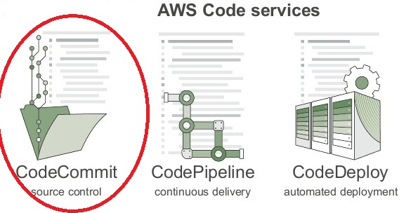

The AWS CodeCommit service allows an enterprise to securely import and host scalable, private Git code repositories. A developer creates a repository through the AWS command-line interface (CLI), software development kit or CodeCommit APIs. Git, an open-source version control system, integrates with CodeCommit repositories using its CLI and several Git clients. CodeCommit also supports several Git commands and works with Jenkins, an open source tool for continuous integration.

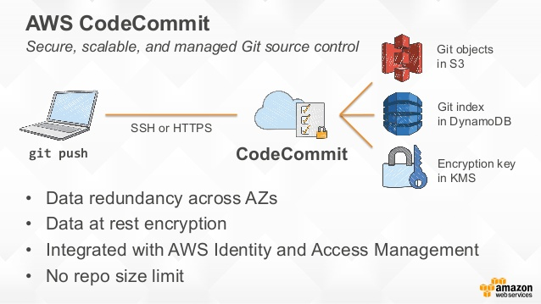

Repositories stored in AWS CodeCommit have no size limits and can scale to meet customer needs. A developer or Web designer can store any type of file up to 2 GB in CodeCommit.

AWS CodeCommit stores data in Amazon Simple Storage Service and Amazon DynamoDB. CodeCommit automatically encrypts files and repositories at rest through AWS Key Management Service. Additional security can be implemented by integrating CodeCommit with AWS Identity and Access Management, which allows an administrator to assign user-access policies and establish multi-factor authentication. An administrator can use either HTTPS or SSH to communicate with CodeCommit.

**benefits**

* **Managed Service:** CodeCommit is fully managed, distributed, and fault-tolerant and carries no administrative overhead. It is elastic and, as mentioned, integrated with other AWS Services.
* **High** **Availability**: Data is replicated across availability zones.
* **Store** **Anything**: Not just source code, but documents and binary files, too. There is no limit to the size of a repo.
* **AWS** **Security**: CodeCommit is integrated with AWS IAM. Data is encrypted at rest.
* **Git** **Compatible**: Users can migrate their existing Git repositories.

**AWS CodeCommit limits**

* CodeCommit is available only in **Virginia (us-east-1)** region.
* A single file in a repository cannot be more than two GB in size.
* An individual commit object, tag, or tree cannot exceed six MB.
* You can have maximum of 1000 repositories per AWS account.CodeCommit is available only in the **Northern Virginia** region.

**AWS CodeCommit pricing**

AWS CodeCommit users eligible for the free tier can have five active users, 50 GB per month of storage, and 10,000 Git requests per month for free. Right now, this rate is available to both new and existing customers. Beyond that, AWS CodeCommit costs $1 per active user per month, which comes with ten GB per month of storage and 2,000 Git requests. Additional storage will be charged at $0.06 per GB-month and $0.001 per Git request.

